The Path Forward:

A Report on Village

Sidewalks

Prepared by the Village of Yellow Springs Planning Office

# Introduction

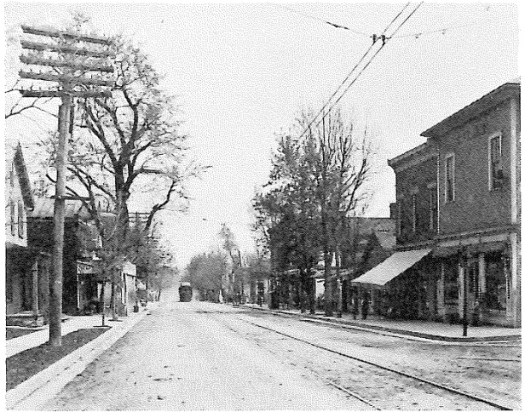Sidewalks, where they exist, are firmly within the dynamic range of the public and the private realms. The public realm, the street and public infrastructure such as utilities, provide the access and means of value for the private realm, the land owned by the individual. Without access to a public way, the value of private property is diminished or eliminated. Most old maps would even show that the property owner owned property into the centerline of the street. Development traditionally involved a developer who would construct the street and utility assets for a section of a municipality as part of a development. Once the infrastructure was completed to the municipalities’ specifications, the municipality would dedicate the infrastructure and assume the maintenance responsibility.

*Xenia Avenue 1902*

Sidewalks exist in most places in between this process. They are required by many places (Yellow Springs included); however, in the majority of places their repair and upkeep has been the responsibility of the adjacent property owner. This is affirmed by a U.S. Supreme Court decision in the 1917 case of Town of Minden V. Stewart et. Al.

Historically, sidewalks have been in existence since the Roman Empire. In late 19th century London a streets corporation was formed to install pedestrian ways as a means of separating people from the bustling streets of the city. Until the installation of public sewers in the late 19th century, many city streets had lingering problems with animal excrement, junk and other unsanitary conditions. Walking paths were installed along the sides of streets that were separated by a curb as a way to elevate and segregate the pedestrian from the street.

Sidewalks provide value to both the private realm and the public realm. The historical argument for adjacent property owner responsibility of sidewalks is that the sidewalk provides pedestrian access separated from the street. For thousands of years the primary mode of transportation for human beings was walking. In the late 19th century, traction cars (trolleys, streetcars, etc.) and trains began to appear in towns (including Yellow Springs). Sidewalks served as valuable access to these services as well as to downtown merchants and markets.

However, in the early 20th century, the rise of the automobile began to transform how people utilized transportation. The horse and buggy and the automobile had once been the domain of the wealthy elite but was available the working middle class via the rise of credit and installment loans. After World War II the automobile clearly became the dominate mode of transportation in United States.

But that did not diminish the value of the sidewalk. Through the latter half of the 20th century communities either viewed sidewalks as perks for high end residential subdivisions or negatively as allowing undesirable people into a residential neighborhood. Because of this, sidewalks thrived as rebranded leisure pathways in high-income and often gated areas but were never constructed in other communities.

Trends and preferences began shifting through the early 2000’s as people began to realize the benefits of sidewalks in communities. Federal transportation programs such as Safe Routes to School were developed to encourage school children to walk to school through programs, partnerships and the repair or installation of new sidewalk. In 2011, the Village was awarded a Safe Routes to School grant to construct new sections of sidewalk in the village.

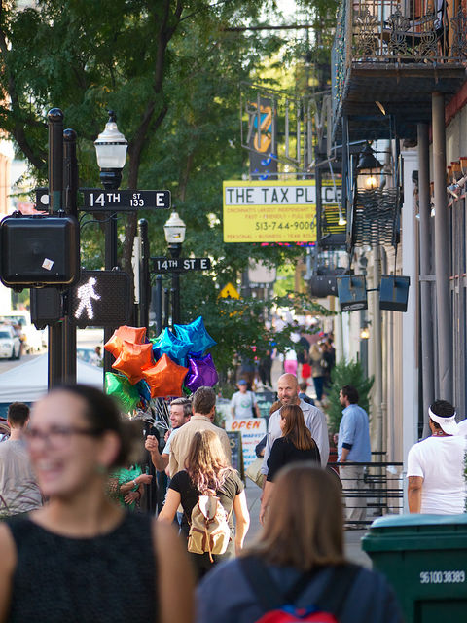Studies done by the AARP, Urban Land Institute, The American Planning Association (APA), and other groups have found that a demographic shift is happening within the country. As the baby boomer generation ages, they begin to move further away from utilizing the automobile as their primary means of transportation. Additionally, the millennial age group, those born between 1980 and 2000 has delayed obtaining drivers licenses and are driving, as a whole, fewer miles than the same age group did in the early 1980’s.

The conclusion typically reached is that sidewalks are for everybody and safe sidewalks benefit everybody. The primary benefit of sidewalks is that they separate pedestrians from automobile traffic. Secondary benefits include health benefits through walking, environmental benefits through reduced vehicle use, and real estate value by offering connectivity for residential properties and economic opportunities for commercial properties in downtowns and neighborhood business districts.

*Photo by Travis Estell*

# History of Village Public Sidewalk Discussions

The Village began to inventory its sidewalk system in 2005 and began developing a sidewalk replacement policy in 2007-2010. During this time Assistant Village Planner Ed Amrhein developed a policy that would notify adjacent property owners of sidewalks in need of repair. However, Village Council began to discuss going in a different direction.

In 2011 the Village Council voted to remove the bolded sentence section from Section 660.05 of the Village Ordinances. Prior to the change the section read:

*“No owner or occupant of abutting lands shall fail to remove accumulated snow and ice from the sidewalk within twenty-four hours of the cessation of a snow or ice fall,* ***nor fail to keep sidewalks in good repair and free of any nuisance.”***

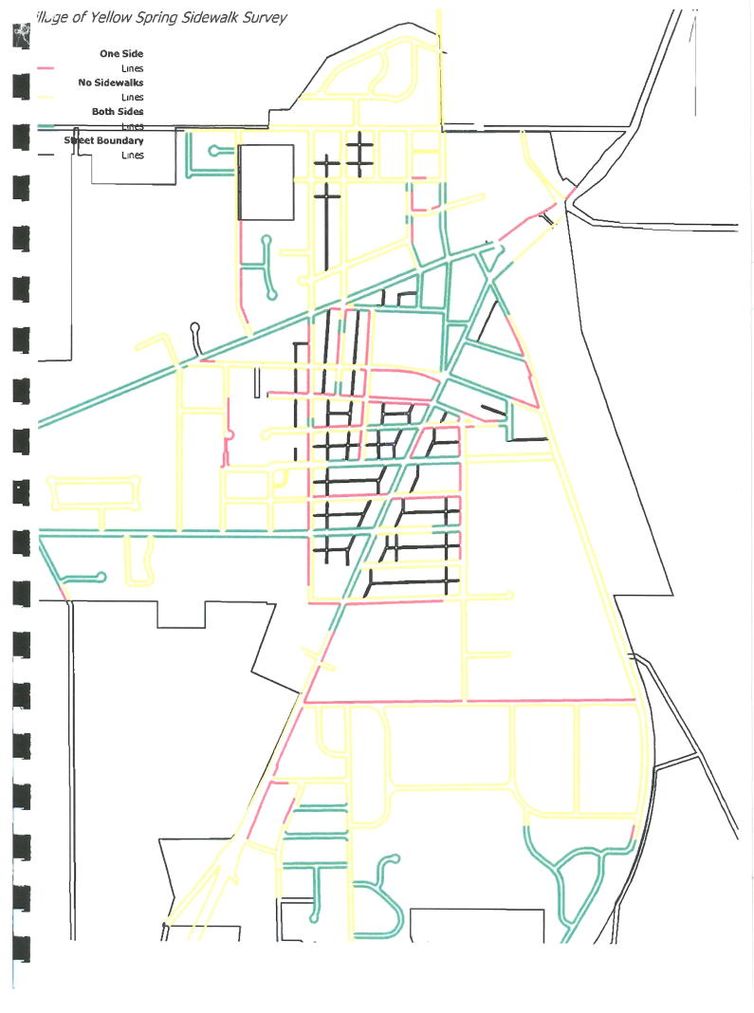The logic behind this move was expressed by then Village Manager Mark Cundiff. In the meeting minutes from the February 2011 Council meeting, he stated that sidewalks should be treated like Village streets since they serve a public purpose and are a public good. Mr. Cundiff also indicated that the policy would only apply to existing sidewalk infrastructure and that new sidewalks would be regulated through approvals of future developments. His plan to fund the maintenance of sidewalks was to be accomplished within the village’s line item for sidewalks which at the time was $30,000. He stated to Council that the amount would be evaluated every year.

However, over the past few years, Village staff has found that the needs of maintaining sidewalks greater than the provided budget. Additionally, last year each Village department was asked to trim 3% of their budget in anticipation of projected budget deficits. It is unclear if the Village will have funding for the sidewalk program over the next few years.

Despite funding shortfalls, the Village has been able to obtain grants to install new sidewalk infrastructure. The Village is currently coordinating with the Ohio Department of Transportation (ODOT) to install new sidewalk on some sections of Fairfield Pike and N. Winter Street as part of the Safe Routes to School Grant. Additionally, the Village was successful in receiving some Community Development Block Grant (CDBG) funds to install ADA compliant curb ramps in downtown and along Xenia Avenue.

*The most recent Village Sidewalk Map from 2009. A larger version is at the end of this report.*

# Goal of Study

The goal of this study is to assess the options for the Village in moving forward with a strategy to adequately and responsibly maintain and grow the Village’s sidewalk network. The study will not present an overall recommendation since the purpose of this report is to gather information on existing conditions, historical information, and present case studies and options for a path forward through the discussion.

# Existing Conditions

According to an inventory conducted by Village staff earlier this year the village has 17.2 miles of sidewalks or 90,784 linear feet of sidewalk. Recent sidewalk repair quotes from village sidewalk projects have pegged the cost of repair at about $12 per linear foot.

The village also has some curb ramps at intersections. There are 164 intersections where there are existing sidewalk crossings and potential crossings. Many of these will either need to be installed or may need replacement and upgrade to meet ADA standards. Recently the Village received CDBG funding to replace some curb ramps in the downtown area. The quote from that project was at $600 per curb ramp.

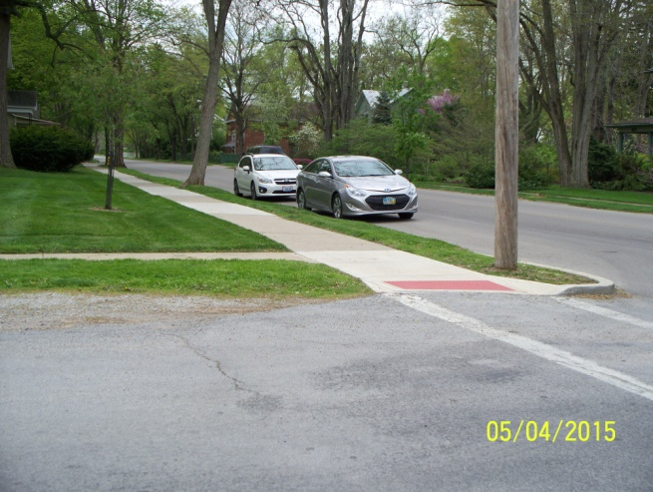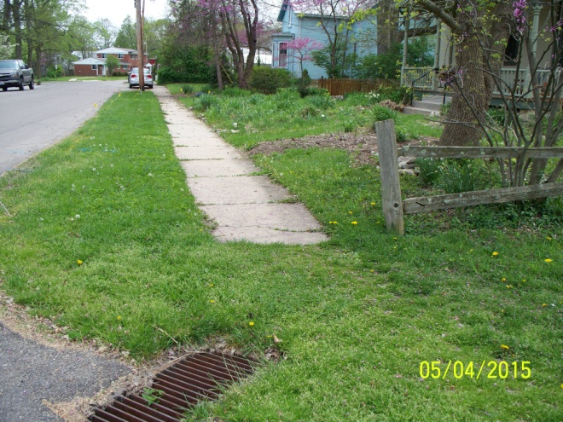Additionally, the Village has budgeted $30,000 to $50,000 for sidewalk repairs over the past four budget cycles. The current budgeted amount is enough to cover approximately two village blocks of sidewalk repair.

# Current Requirements & Considerations

*New sidewalk and ADA ramp at Xenia Avenue*

*Sidewalk ending at drain on Walnut*

The Village’s current subdivision regulations (Section 1226.06(a)(3)) require:

* A minimum of 4ft wide sidewalk be installed on at least one side of the street for new public streets.
* Blacktop can be substituted for concrete.
* Estate streets are exempt from sidewalk requirements unless required by Planning Commission.

The American Planning Association (APA) recommends:

* A minimum of 4ft width for local residential streets.
* A minimum of 8ft for commercial streets.
* A minimum of 12ft for downtown business districts.

The Americans with Disabilities Act (ADA) requires:

* A minimum of 5ft for wheelchair turning radius.
* If sidewalks are narrower, turning islands must be spaced every 200 ft.
* Sidewalk must be a minimum of 3ft in width and allow at least 3ft around obstacles in or next to sidewalks (i.e. trees, light poles, etc.).
* Appropriately designed curb ramp assembly for intersections.

The Federal Highway Administration (FHWA) strongly recommends a minimum sidewalk width of 5ft. for all applications. All sidewalks that are installed with federal funds such as the Safe Routes to Schools Project are required to be at least 5ft wide. Links to these regulations are included at the end of this report.

# Case Studies

## Los Angeles California

In the 1970’s the city of Los Angeles took responsibility for city sidewalks around street trees when federal grant funding allowed the city to fix sidewalks damaged by its street trees. However, after a few years that funding dried up and the city was left with the responsibility of maintaining the sidewalks. Over the next few decades there were several efforts to continue funding sidewalk repair. A 1998 move to authorize $796 million in sidewalk repairs was rejected. The little money that was budgeted for sidewalk repairs dried up during the Great Recession and in 2014 lawmakers abandoned a plan that would have asked voters to pay for street and sidewalk repairs by increasing the sales tax. Trip and fall lawsuits from damaged sidewalks have cost the city $6 million in the last four years.

In early April 2015, the city reached an agreement regarding a federal court case that brought a lawsuit on the city for not complying with the Americans with Disabilities Act standards. Advocates stated that handicap and wheelchair bound individuals were relegated to second –class citizens due to the condition of the city’s sidewalks. About 40% of the city’s sidewalks are in disrepair. The agreement states that the City will spend $1.3 billion over the next 30 years repairing its sidewalk system. The city will spend $31 to $63 million per year over the next thirty years to maintain its sidewalk system. So far no funding source has been identified.

## Austin Texas

Austin adopted responsibility for sidewalk repairs in the mid 1990’s. However, it did not appropriate funding for sidewalks until the 2000’s. The city also adopted legislation that required new sidewalks to be developed with mixed-use developments which led to a patchwork of incomplete sidewalk networks in the city. In 2009 the city adopted a sidewalk master plan which found that the city would have to add an extra 3,500 miles of sidewalk to connect their sidewalk system together. The new sidewalk would cost $824 million on top of funding maintenance of existing sidewalks at $120 million. The city currently budgets $5 to $10 million for sidewalks.

# Outline of Strategies

## Option 1 – Village Raises Funding and Maintains Existing Sidewalk Network

### Upgrade all existing sidewalks to meet ADA standards.

This option would replace all sidewalks to meet minimum ADA standards (5 ft. X 5ft. sections every 200 ft.) in residential. This option assumes all existing sidewalks will be replaced over the expected lifespan of a concrete sidewalk which is 25-30 years.

**Total linear foot of sidewalk:** 90,784 ft.

**Total square footage of sidewalk to be replaced/reconstructed:** 393,094.72 square feet

**Cost of sidewalk per square foot:** $12 a square foot*

**Total cost of sidewalk repair & maintenance**:** $4,717,136.64

**Total amount of crosswalk ramp:** 164

**Average cost to install/replace ramp:** $600

**Total cost to replace/install all ramps:** $98,400

**Total Repairs in today’s dollars:** **$4,815,536.64**

* Based on streetscape contractor estimate for concrete sidewalk work.

** The total cost is derived by a calculating a section of sidewalk that is 1,000ft long. At every 200ft interval there is a 5X5 sidewalk to conform to ADA recommendations. So there are 5 5X5 blocks per 1,000ft of 4ft wide sidewalk. Therefore, 125ft of sidewalk will be 5ft. X 5ft. and 87ft of sidewalk will be 4ft wide. This is used to calculate the average width of sidewalk. (5 X 125) + (4 X 875) = 4,125 square feet of sidewalk per 1,000 linear feet. The average width of sidewalk is 4.125 however the calculation is adjusted to 4.33 to account for commercial district sidewalks and the need for contingency funding (i.e. special situations such as sidewalks affected by tree roots, etc.)

## Option 2 – Village Returns Sidewalk Responsibility to Home Owner

### Village maintains responsibility for sidewalks on Village owned property and ADA crosswalks.

Under this policy option the Village would maintain responsibility for sidewalks on Village owned property such as parks and the Bryan Center. The Village would also maintain curb ramps to ensure that street crossings are compliant with ADA requirements.

However; sidewalk maintenance responsibility would be returned to the property owner.

Village staff would have the opportunity to develop a program to encourage property owners to repair and replace the existing sidewalks. The program could include incentives such as piggy-backing on a Village concrete bid for lower pricing and/or possible cost sharing through a Village grant program.

## Option 3 – Current Policy is Maintained

The current policy has been to evaluate how much money the Village can put into the sidewalk maintenance fund during every budget cycle. When the policy change was approved the fund was at $30,000 for the 2011 budget. That number has increased to $50,000 for this year’s budget.

It would take over 90 years to replace all existing sidewalks in the village with the current budgeted amount. This calculation includes increases in funding from inflation.

# Legal Liability & Insurance

Village staff consulted with the Village Solicitor’s office regarding the potential or historical exposure to the Village in litigation on sidewalks. Recent court cases have determined that the Village would not be held liable for accidents on the sidewalks; however, the Village would face increased insurance rates as these incidents are counted as insurance claims for the Village. It is not possible to determine exactly how much the Village’s insurance would go up over time but the cost increase will continue to occur as long as the village has maintenance responsibility of sidewalks.

# Funding Options

## If Village Maintains Responsibility

* Tax Levy Income
  + The Village Council can decide to put a tax levy on the ballot for up to five years. The levy would be based on the appropriate millage for the cost of sidewalk replacement and could include the potential for new sidewalk construction.
* Increase taxes
  + The Village Council can decide to raise either property tax or income tax to fund sidewalk repair and replacement.
* Issue Bonds
  + Bonds can be issued in conjunction with a levy or tax increase. The bond would cover the cost of sidewalk construction/reconstruction and curb ramp installation.
  + Since little to no revenue is generated through the construction of sidewalks, it would not be advisable to issue bonds without some financing aspect in place to fund the bond payments.
* “Fee in lieu” Fee
  + The village passes regulations that allow developers and property owners to pay a fee to forgo sidewalk construction along their property and instead direct those funds towards funding sidewalks installation and repair on arterial connections.

## If Village Returns Maintenance to Property Owner

* Sidewalk assessment on adjacent property owners
  + The Village staff could finance sidewalk repair by assessing individual property owners for the repair of damaged sidewalk. These costs would be paid by the property owner on their tax bill.
* Self-assessed property owner tax
  + The owner would perform their own tax assessment voluntarily to pay for sidewalks. This is usually done when the municipality is repaving or reconstructing a street and the property owner has an opportunity to repair the sidewalk.
* Cost-sharing with property owners (50/50 split)
  + The municipality splits the cost of sidewalk repair evenly with the property owner. This is the policy in several municipalities (Chicago, San Diego, Boulder, among other townships and smaller municipalities).

## Both

* Grant Funding
  + The Village would pursue grant funding in the form of Safe Routes to Schools Grants and Community Development Block Grant funds among others.

# Findings and Discussion

The numbers presented above show different options for sidewalk maintenance. It unfolds the problem with options and different levels of village funding and commitment. However, the above strategies do not consider the possibility of expanding the Village’s sidewalk network to other parts of the village that do not have sidewalks.

Table one highlights the level of funding needed to replace all the existing sidewalks within a certain time frame. The amount is calculated based on the total present value to replace the sidewalk system which is $4,815,536.64. The funding amount is subtracted by year and accounts for inflationary increases in the cost over the duration of the funding cycle.

|  |  |  |  |  |
| --- | --- | --- | --- | --- |
| Time Frame | Current Funding ($50,000 + 2% inflation) | 30 year | 10 year | 5 year |
| Funding Amount | $50,000 + 2% increase | $206,000 | $483,000 | $843,000 |
| Duration of Funding | 96 years | 30 years | 10 Years | 5 years |
| Total Spent | $14,336,318.64 | $6,386,000.00 | $5,313,000.00 | $5,058,000.00 |

*Table 1*

Based on conversations with staff and discourse from past and current councils, the following values have also been expressed:

* **Walkability:** A goal of both the Yellow Springs Comprehensive Plan and the Yellow Springs and Miami Township Vision document.
* **Accessibility:** Having adequate access by handicapped individuals in wheelchairs, on crutches, etc.
* **Legal Liability:** and providing adequate accessible facilities.
  + A recent federal court settlement in Los Angeles exposes potential liability for municipalities whose sidewalks are not adequate for accommodating wheelchair bound individuals under ADA.
* **Funding:** The Village currently does not have the funding in place to adequately maintain sidewalk infrastructure.
* **Equity:** Determining whether the option would treat all villagers fairly regardless of income, race, religion, etc.

These values are used in Table 2 which attempts to score how well each value criteria would be for each option. Values are rated from 1 which means the option does not meet the criteria to 5 which mean the option fulfills the criteria. The highest scoring option would be considered the most practical course of action as of this report.

|  |  |  |  |  |  |  |
| --- | --- | --- | --- | --- | --- | --- |
| Options | Walkability | Limit Legal/Ins. Liability | Funding  Availability | ADA Compliance | Equitable | Total |
| Fund Repair | 5 | 3 | 1 | 5 | 4 | **18** |
| Return Responsibility | 3 | 5 | 5 | 3 | 3 | **19** |
| Status Quo | 2 | 1 | 1 | 2 | 2 | **8** |

*Table 2*

The table illustrates that both the option for the village to fund repairs and the option to return the sidewalk responsibility to the property owner are more desirable than the current policy on sidewalks. The rating for the category of walkability looks at how well the option would encourage walkability. A score of 5 means that the sidewalks are in good maintenance and the network is complete. For legal liability, a score of 5 indicates that the option would minimize legal liability to village.

A 5 for Funding Availability means that funds are readily available. This is why Option A, funding the repair scored a 1. The funds would have to be raised through a levy ballot or raising other taxes. Since that has not been accomplished, the strategy is the least viable for funding.

A score of 5 for ADA compliance means the plan ensures compliant compliance with the American’s with Disabilities Act. For Equitable, a score of 5 means the plan is fair to everyone.

The analysis shows that Option B, returning responsibility to property owners scores the highest however Option A, to find funding for repairs through a tax levy or tax increase is close as well.

# Next Steps

Regardless of which direction Village Council decides to go, staff recommends that the following be pursued:

* The development of a Sidewalk Master Plan that would include:
  + Complete inventory of existing sidewalk conditions.
  + An inventory of potential sidewalk locations.
    - Identify where potential sidewalks can go and cannot go.
* The adoption of updated sidewalk construction standards for new developments.

If the Village Council decides to move forward with adopting a funding strategy for sidewalks it must be determined if the strategy will include the construction of new sidewalks in addition to the maintenance of current sidewalks in the Village. It should also be determined to what degree new sidewalks will be installed. Will they go on every street? Should there be a tiered system where sidewalks are required in certain places but not others?

Once this is determined, Village Council would have to identify the appropriate funding mechanism to fund the maintenance and replacement program.

If the Village Council decides to pursue returning sidewalk maintenance to the adjacent property owners, then a policy would have to be devised on how to enforce that responsibility. Some pamphlets on cost sharing and bid sharing are included with this report.

If you have any questions please feel free to contact me by phone at (937) 767-1702 or by email at [jyung@vil.yellowsprings.oh.us](mailto:jyung@vil.yellowsprings.oh.us).

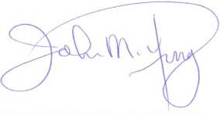Respectfully Submitted,

John M. Yung, AICP  
Assistant Village Manager

# References

<http://www.fhwa.dot.gov/environment/bicycle_pedestrian/publications/sidewalks/chap4a.cfm>

<http://guide.saferoutesinfo.org/engineering/sidewalks.cfm>

<http://www.pedbikesafe.org/PEDSAFE/resources_guidelines_sidwalkswalkways.cfm>

<https://www.planning.org/pas/at60/report95.htm>

<http://www.nj.com/news/index.ssf/2012/07/amid_slippery_laws_towns_take.html>

<http://www.latimes.com/local/lanow/la-me-ln-lawsuit-broken-sidewalks-20150331-story.html#page=1>

<http://www.pedestrians.org/retrofit.htm>

<https://books.google.com/books?id=jPpMqyLOd74C&pg=PA118&lpg=PA118&dq=E.+L.+Stewart+of+Minden&source=bl&ots=2x4-t4jOLJ&sig=8VPLP4PLvENu27u4wgsHWzVJ6pI&hl=en&sa=X&ei=GzADVeCHGcW-ggS2iIHYBw&ved=0CCwQ6AEwAw#v=onepage&q=E.%20L.%20Stewart%20of%20Minden&f=false>

<http://www.citylab.com/tech/2014/05/the-sidewalk-of-the-future-is-not-so-concrete/371377/>

<http://www.austinchronicle.com/news/2014-07-11/where-the-sidewalks-end/>

<http://www.fhwa.dot.gov/environment/bicycle_pedestrian/publications/sidewalks/chap4b.cfm>

<http://www.ite.org/CSS/online/DWUT08.html>

<http://thecityfix.com/blog/the-eight-principles-of-the-sidewalk-building-more-active-cities-paula-santos/>

<http://activelivingresearch.org/sites/default/files/ALR_Infographic_Transportation_July2012.jpg>

<http://www.pedestrians.org/retrofit.htm>

<http://cityofmentor.com/live/sidewalk-repair-program/>

<http://nextcity.org/daily/entry/walkability-cities-sidewalk-upkeep-homeowner-responsibility>

<http://www.citylab.com/cityfixer/2015/02/a-community-approach-to-clearing-snow-from-sidewalks/385173/>

<http://www.austintexas.gov/sites/default/files/files/Public_Works/Sidewalk_Master_Plan.pdf>

<http://safety.fhwa.dot.gov/ped_bike/tools_solve/fhwasa13037/chap6.cfm>

<http://chi.streetsblog.org/2014/01/02/eyes-on-the-street-gravel-sidewalk-at-plaza-site-forces-people-into-street/>

# Appendix A – Sidewalk Construction Materials Chart

|  |  |  |  |  |  |
| --- | --- | --- | --- | --- | --- |
| Type | Cost | Lifespan | ADA Compliant | Maintenance | Water Permeable |
| Concrete | $12-$17 per linear foot. | Average 25-30 yrs. Up to 75 yrs. | Yes | Moderate | No |
| Rubber | $24-$32 per square foot. | 7-10 yrs | Yes | None | No |
| Brick/Cobblestone | $16-$20 per linear foot | 100+ years | Yes if maintained | High | Moderate |
| Permeable Pavement | $13-$20 per linear foot | 25-30 years | Yes | Moderate | Yes |

Table 3