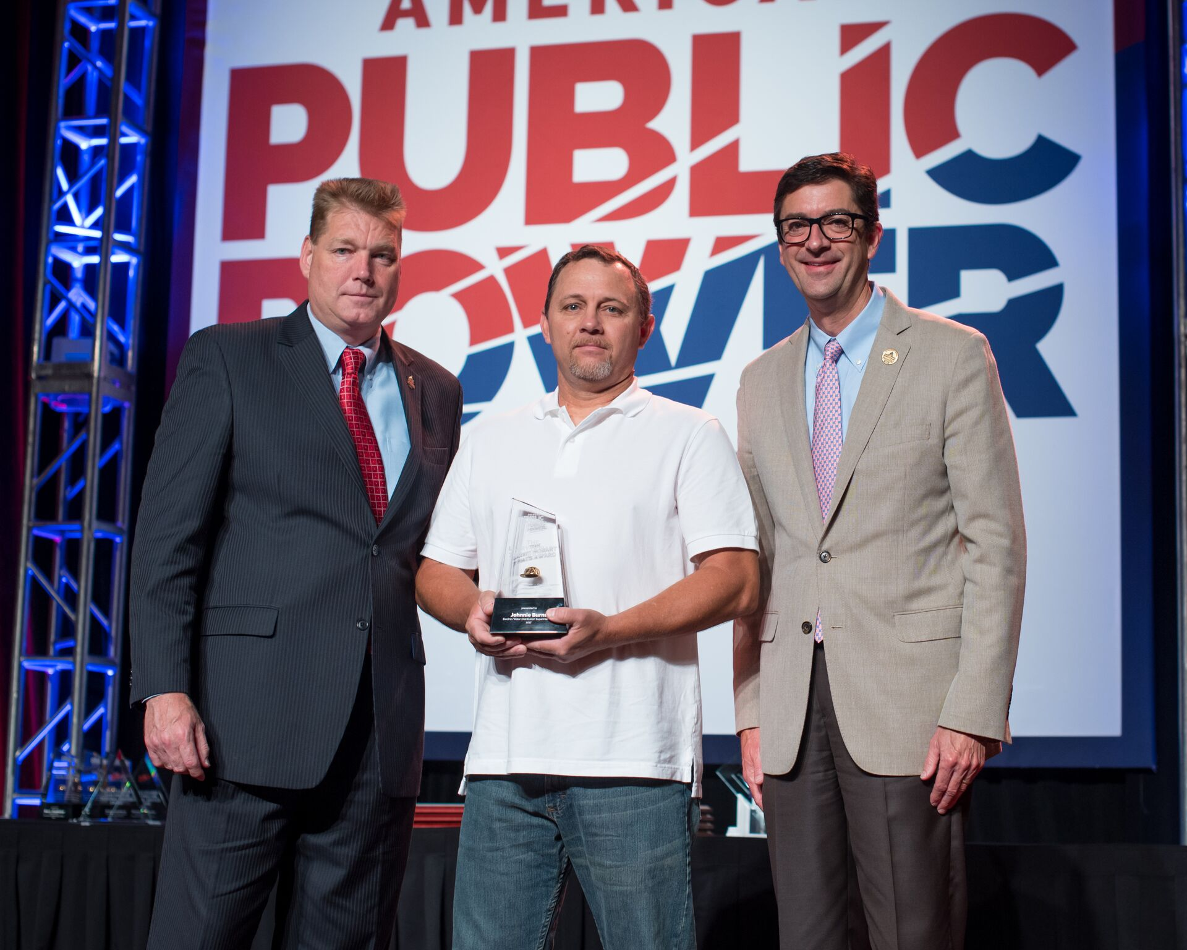

Electric Superintendent for Village of Yellow Springs receives national award

Orlando, Fla., June 20, 2017 —Johnnie Burns, Electric Superintendent for the Village of Yellow Springs, Ohio, received the Larry Hobart Seven Hats Award at the American Public Power Association’s National Conference in Orlando, Florida. This award recognizes managers of small utilities serving fewer than 2,500 meters. These managers have a very small staff and must assume multiple roles. The seven hats they must wear are: planning and design, administration, public relations, field supervision, accounting, human resources, and community leadership.

Described by colleagues as “the very definition of a working superintendent,” Burns personally responds to citizen concerns and provides positive leadership to his staff. Working on both the electric and water distribution systems, he takes a hands-on approach, which brings him into the field with his crews daily. He performs field duties ranging from flagging traffic to climbing utility poles, all while managing the village’s 4.5 million dollar electric budget. He also plans and helps design improvements for the utility’s multiple systems, including a one-megawatt solar array.

###

The American Public Power Association is the voice of not-for-profit, community-owned utilities that power 2,000 towns and cities nationwide. We represent public power before the federal government to protect the interests of the more than 49 million people that public power utilities serve, and the 93,000 people they employ. Our association advocates and advises on electricity policy, technology, trends, training, and operations. Our members strengthen their communities by providing superior service, engaging citizens, and instilling pride in community-owned power.

