eGov Manager™ v6.0

ENTERPRISE PAYMENT PORTAL
System User Guide (v 1.1)
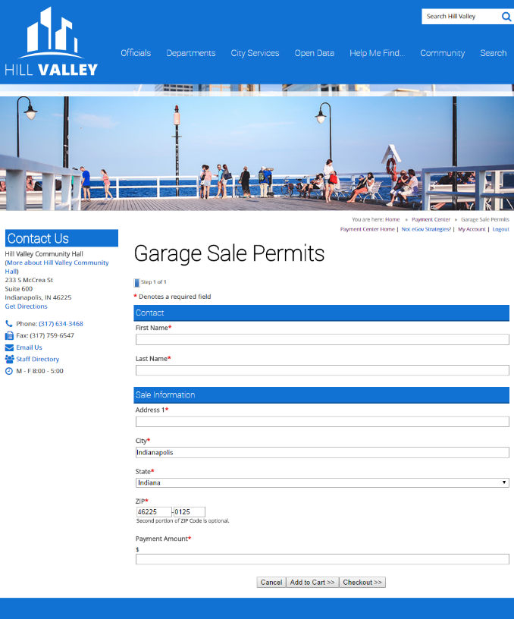
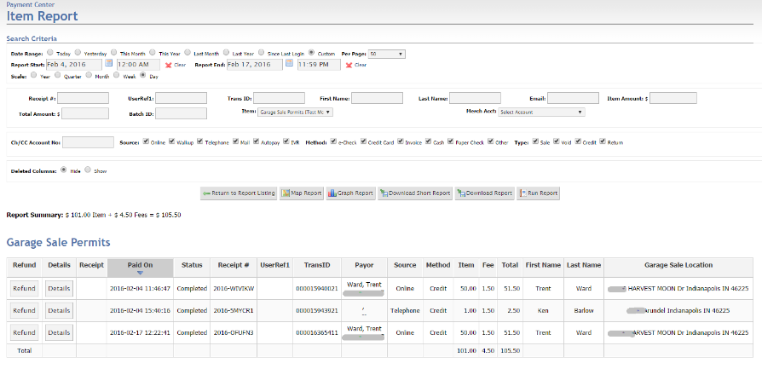
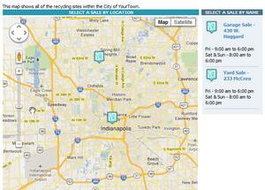

The Online Payment Portal For Harris County, Texas

TABLE OF CONTENTS
Getting Started with The eGov Manager (incomplete) 4
Access to the New Website and eGov Manager Website Management System 4
Usernames & Passwords 4
Resetting Username or Password 5
Process for Resetting a User Account via Email 5
Changing Your Password or Account Information 5
Citizen Access to Government Payments (incomplete) 6
The Harris County Payment Portal 6
Benefits of Creating an Account 6
Types of Payment Items 6
The Online Payment Process 6
Confirmation Messages 7
Taking Payments within the System 8
Accept Payments Functions 8
Selecting a Payment Item Button 8
Selecting the Accept Payments Function 9
Completing Payment Form Pages 9
Checkout Page 10
Review Items – Confirmation of the Payment Amount & Service Fee 10
Payment Information – Provide Credit Card or Check Information 10
Entering Payment Information via data Entry 12
Service Fee Calculation 12
Completing the Payment Information Page 12
About the Billing Information 13
Confirmation Page 13
Payment Rejections 14
How Payments Appear on Credit Card Statements 14
Managing Payment Items & Their Users 15
Adding eGov Manager Users 15
The Add Option under “Users” 15
Process for Adding a New User 16
Modifying Your Organization’s Payment Items 16
Process for Viewing and Modifying Your Payment Items 16
Modifying Payment Items 17
General Tab 17
Confirmation Tab 17
User Access Tab 17
Inactivating Payment Items 18
Set the Payment Item to be Inactive 19
Adjust the ‘Available to Public’ Setting 19
Reports & Refunds 20
Accessing Reports 20
Quick Access to Reports from ‘Payment Functions’ 20
Selecting the Reports Function 21
Item Report: Generating a List of PAYMENTS with Details 21
Showing Details within an Item Report 21
Searching for a Transaction Using the Item Report 22
Getting More Details & Generating a Receipt 23
Key Sections within the Item Details Page 24
Viewing or Printing a Receipt 24
Voiding a Transaction or Issuing a refund 25
Finding the Transaction 25
Sample Transaction Report 26
Voiding or Refunding the Transaction 26
Void & Refund Policies 27
Settlement Reports 28
Reconcile Credit Card Transactions 29
Reconcile E-Check Transactions 29
Generate a Settlement Summary Report for the Month 29
The Settlment Details Report 30
Note Regarding Credits And Adjustments in Settlement Summary Report 31
Match Deposits to Specific Bank Deposits 31
Contacting eGov Support 33
Information to Provide With Your Support Request 33

Getting Started with The eGov Manager (incomplete)
Cadence Bank is pleased to announce a new service for …

Access to the New Website and eGov Manager Website Management System
- New Harris County payment portal: TBD
- New client website management system: TBD/manager
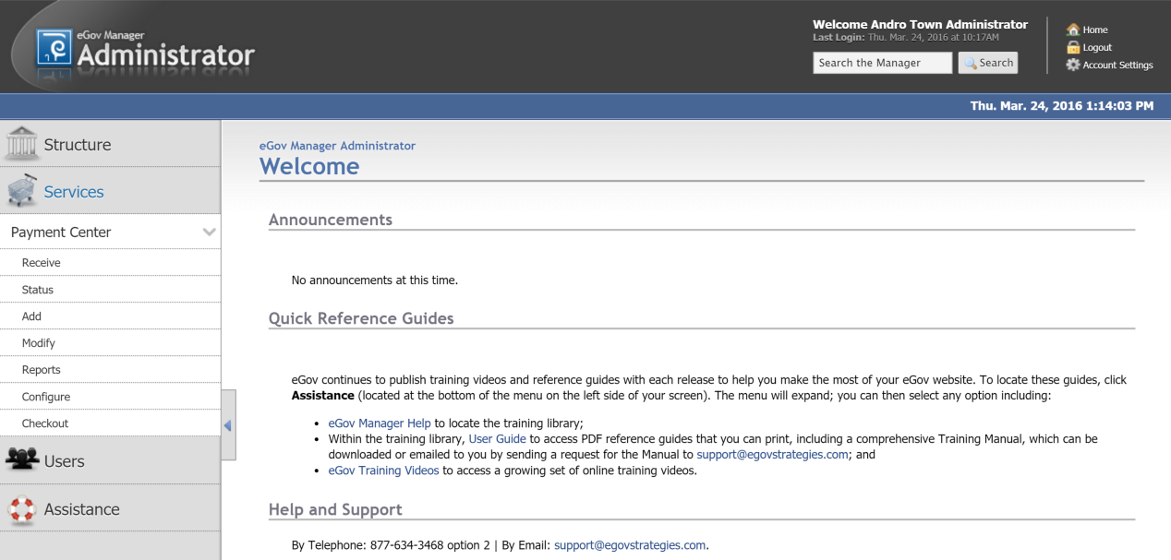

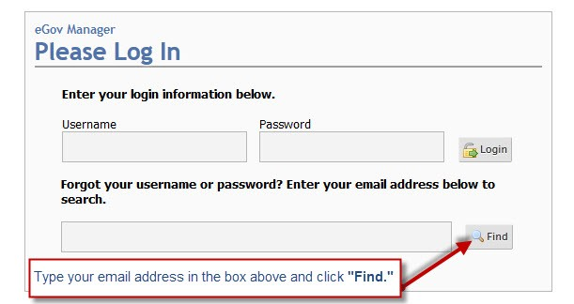
Usernames & Passwords
By default, passwords need to be at least seven (7) characters in length and will require a number or a special symbol.
For PCI compliance purposes, eGov will require that passwords be changed once every six months.
Your initial password will be configured by either the Bank or eGov and you may be prompted to change your password once you’ve logged in to the eGov Manager with your temporary password.

Resetting Username or Password
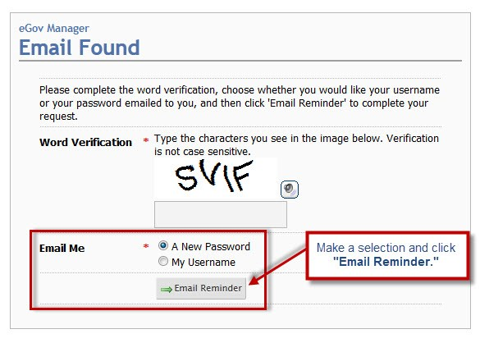
In the event that you do not remember either your username or your password to login to the eGov Manager, do the following:
- Go to the eGov Manager Login screen.
- Type your email address into the space provided under username/password and click Find.
- Select the option to either reset your password or send you your username.
- An email from "Webmaster" will be sent to the email address provided.
NOTE: You may need to wait 1-2 minutes before you receive your email.

Process for Resetting a User Account via Email
Go to the eGov Manager Login Screen: TBD/manager
Find Email Address: for example – kbarlow@egovstrategies.com

Changing Your Password or Account Information
Login to the eGov Manager: TBD/Manager
In Left Navigation, Go to Users > My Password or My Account

Citizen Access to Government Payments (incomplete)

The Harris County Payment Portal
<SCREENSHOT>

Benefits of Creating an Account
- Access to any saved account (e.g. a property tax parcel number or utility bill account number)
- Access to payment receipts
- Ability to manage credit card and e-check payment methods

Types of Payment Items

The Online Payment Process
The online payment process includes the following:
- Search for Account information
- Associate accounts to user account
- Complete various payment form field types
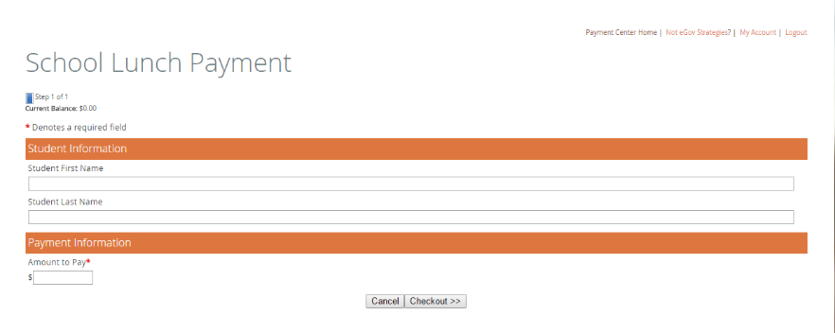
- Pay by credit, debit or ACH (e-check)
- Manage saved payment information
- View payment history and receipts

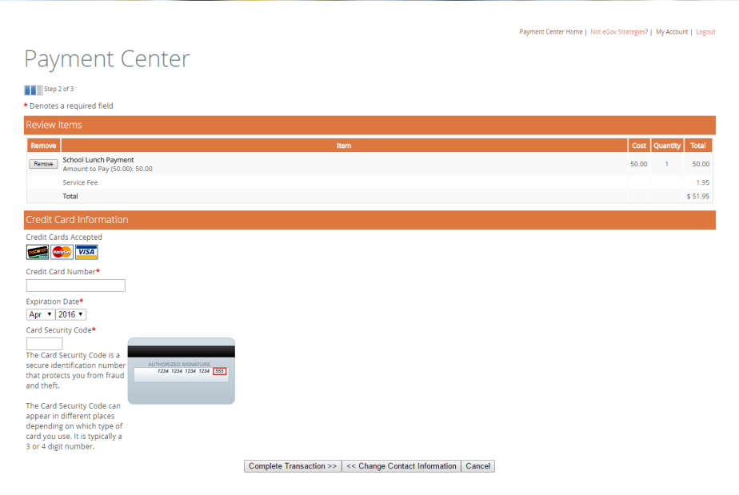

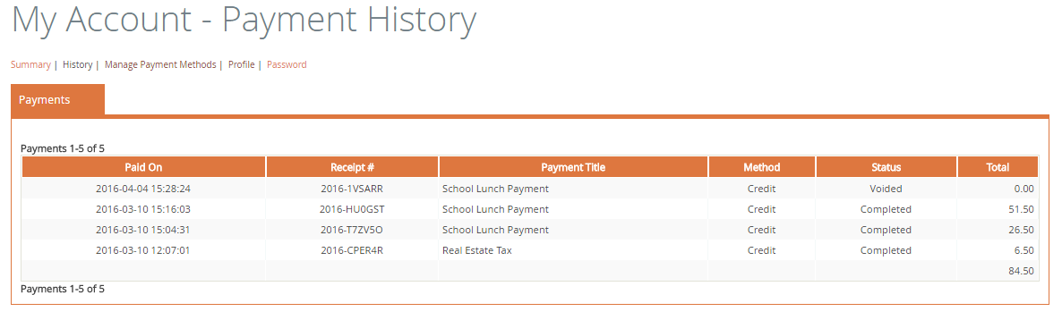

Confirmation Messages
After payment is made, the citizen will receive a confirmation message and an emailed receipt.
- Each payment item’s confirmation message can be customized by AndroGov clients
- Registered users can also access payment receipts via the My Account feature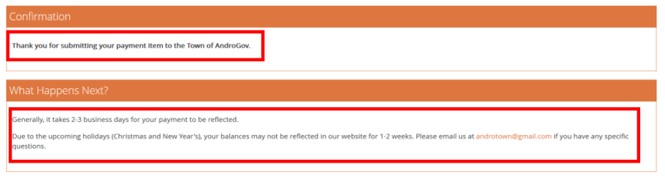

Taking Payments within the System
The Accept Payments function within the eGov Manager enables authorized users to accept “Point-of-Sale” (POS) payments – also referred to as “at-the-counter”, “office use only” or “over-the-counter” transactions – for any payment item. These are payments that are taken for government services from visitors to your office or from constituents calling in by phone.
You can take a POS payment by logging into the eGov Manager.

Accept Payments Functions
After logging in to the eGov Manager, the user will arrive at the eGov Manager home page screen. An authorized staff member can accept payments in 1 of 2 ways (highlighted in the screenshot below):
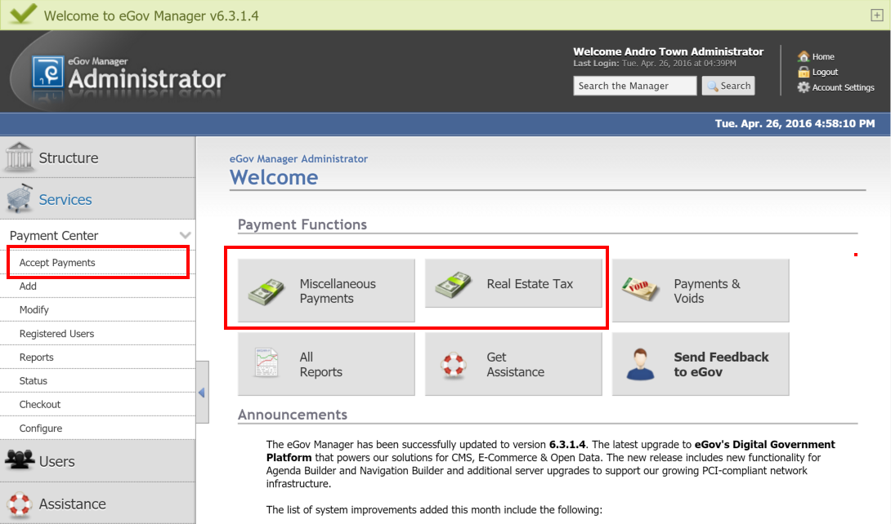

Selecting a Payment Item Button
A user can jump directly to accept payments for one of the authorized payments by selecting a payment button:
- Under the Payment Functions heading, select one of the buttons with a green “cash” icon
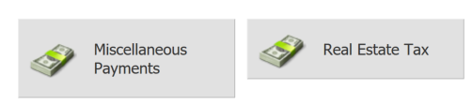
Note that if a user does not have access to accept a specific payment item, please review the “Configuring the Payment Item to Authorize Users” section of this document.

Selecting the Accept Payments Function
- Under Services in the left-hand navigation, select Payment Center
- The menu will expand and then select the Accept Payments option
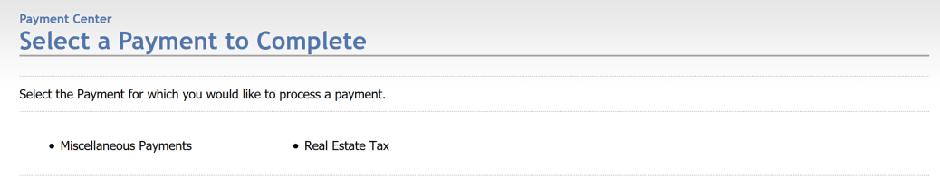
All of the payment items that can be accepted by this user will now appear in the middle portion of the eGov Manager web page. For example, in the screenshot below, this User has been authorized to accept two different payment items: Real Estate Tax and Miscellaneous Payments.

Completing Payment Form Pages
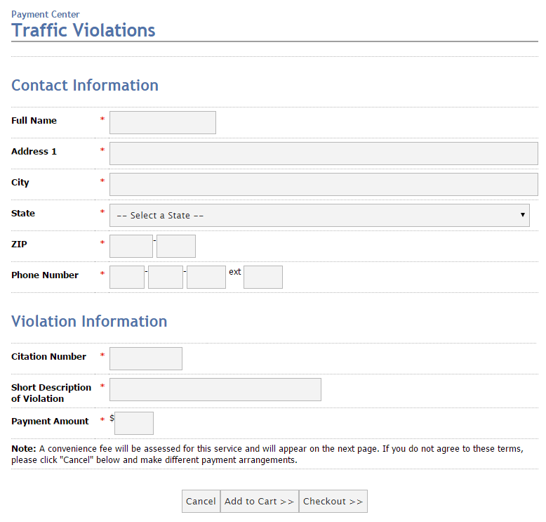
Once a payment item has been selected, the user will be forwarded to complete any fields that have been configured for this specific payment form.
Note that the Payment Form can configured to the specific needs of the client. In its simplest form, the payment item could be configured with:
- Header – for example, Account Information
- Account Number – for the user’s account number
- Payment Amount – can be a drop-down item or a field allowing for free-form data entry
After completing all form fields, select the “Checkout” button at the bottom of the page. Upon selecting that button, the user will be forwarded on to the Check Out page to provide payment information.

Checkout Page

Review Items – Confirmation of the Payment Amount & Service Fee
The top portion of the Checkout Page provides a confirmation of the Payment Amount.
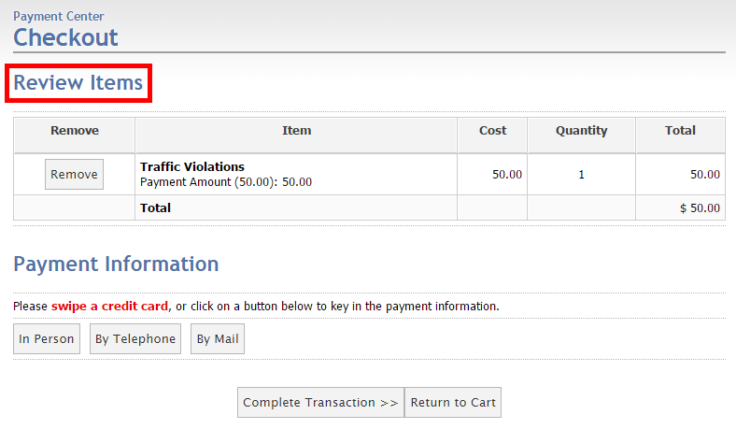

Payment Information – Provide Credit Card or Check Information
After reviewing the payment amount and service fee (if applicable), the next step is to provide payment information – either credit card information or check information. This can be accomplished in one of two ways:
- Using a MAGTEK credit card swipe device; or
- Entering credit card information into the payment form.

Using a Credit Card Swipe Device
If a MAGTEK card reader has been connected to the PC from which you are taking the payment, simply swipe the credit card reader in the MAGTEK device. The following will appear:
- For Payment Method, In Person & Credit will be selected

The following will appear:
Credit Card Information area will appear containing the following:
- Credit Card #
- Expiration Date
NOTE: YOU WILL NEED TO PROVIDE THE SECURITY CODE (BACK OF CARD) –
FOR SECURITY REASONS, THIS IS NOT AUTO-FILLED.
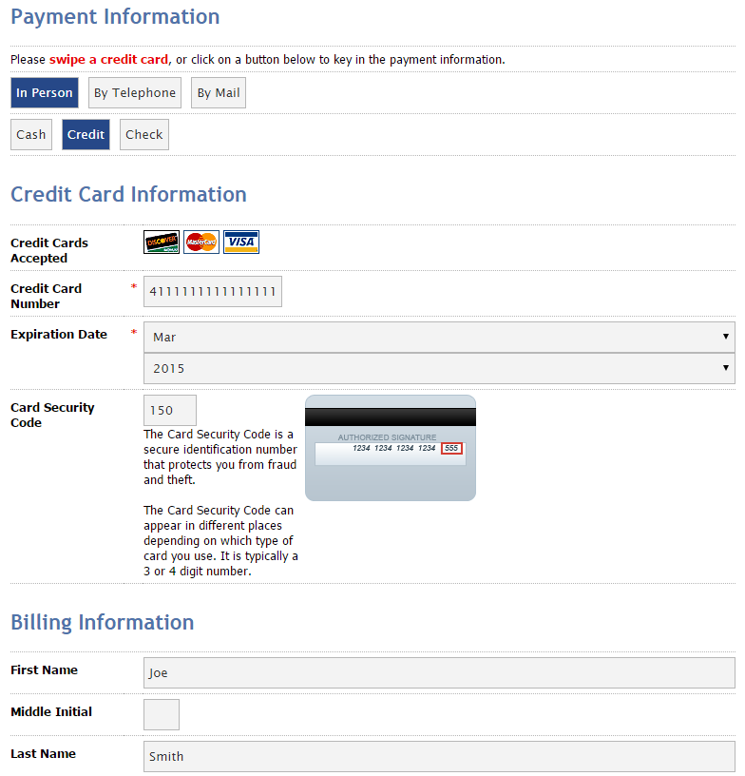
Billing Information
- First Name
- Last Name
- Email Address
- Phone
- Address

Entering Payment Information via data Entry
If a MAGTEK card reader is not being used, simply select the appropriate payment method type:
- In Person – options are Cash, Credit or Check
- By Telephone – options are Credit or Check
- By Mail – options are Cash, Credit or Check

Service Fee Calculation
Once the staff user selects the desired payment method (Credit Card or e-Check), the Item List at the top of the page will refresh to calculate the appropriate service fee for this payment method.

Completing the Payment Information Page
The following will appear:
Credit Card or Check Information
- For Credit Card  - Credit Card #  - Expiration Date  - Security Code (back of the card) | - For Check  - Account Number  - Routing Number
Billing Information

- First Name
- Last Name
- Email Address
- Phone
- Address

About the Billing Information
Although no fields are required within the Billing Information section, please consider the following:
- FIRST NAME & LAST NAME - To search for a payor within the Payment Center Reports, you will need to complete the First Name & Last Name fields within the Billing Information section.
- SENDING A CONFIRMATION EMAIL – In order to send a confirmation email (either to the payor or to send a confirmation email to an office email address), complete the Email Address field within the Billing Information section.

Confirmation Page
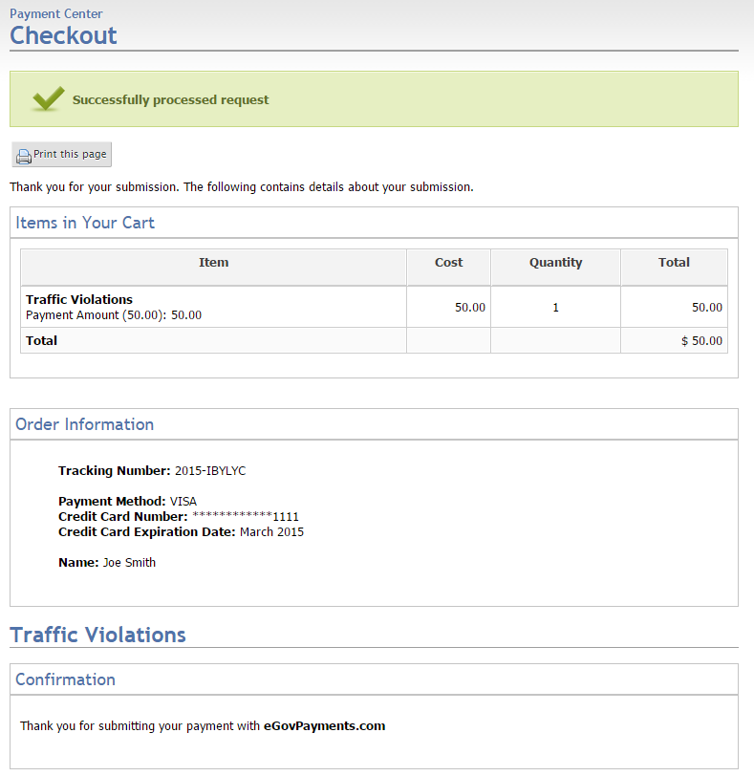
Upon completing the previous page and hitting Complete Transaction button, a confirmation page will be shown.
A similar receipt will also be emailed to the email address provided within the Billing Information section.
The Tracking Number that is listed in the “Order Information” section can be used by staff to look up this payment transaction in the eGov Manager Reports section.

Payment Rejections
In the case of a non-successful credit card transaction, the user will not be forwarded to the confirmation page and instead will get a message in a red box with an X. Possible error messages include the following:
- Credit Card Declined – review the credit card/debit card number, expiration date and security code and re-try the payment. The error could be due to a data entry error or it could be due to insufficient funds in the credit/debit card account. The user should also be advised that some types of “gift” credit cards cannot be accepted by the online payment system.
- Declined Transactions Report – for additional details, you can view a Declined Transactions Report. Look for that special report under the Reports area – select the day of your declined transaction and select the item to view more details.

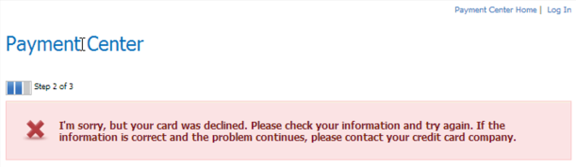
How Payments Appear on Credit Card Statements
Payments will appear on credit card statements as two separate transactions – one entry for the amount of the payment and the second entry for the service fee charged for this service:
Table 1 – Sample Credit Card Statement Entries

Date | Location | Amount
01/01 | ST Your City Name Your City ST | $300.00
01/01 | Egov Service Fee Indianapolis IN | $4.75

Managing Payment Items & Their Users
As a service of AndroGov, the portal vendor eGov Strategies will create and configure all payment items on behalf of clients. If you need a new payment item, please email support@egovstrategies.com or contact your Androscoggin Bank representative.
The new AndroGov portal provides additional capabilities for Payment administrators to customize their payment items to add instructions or additional information as part of the payment form.
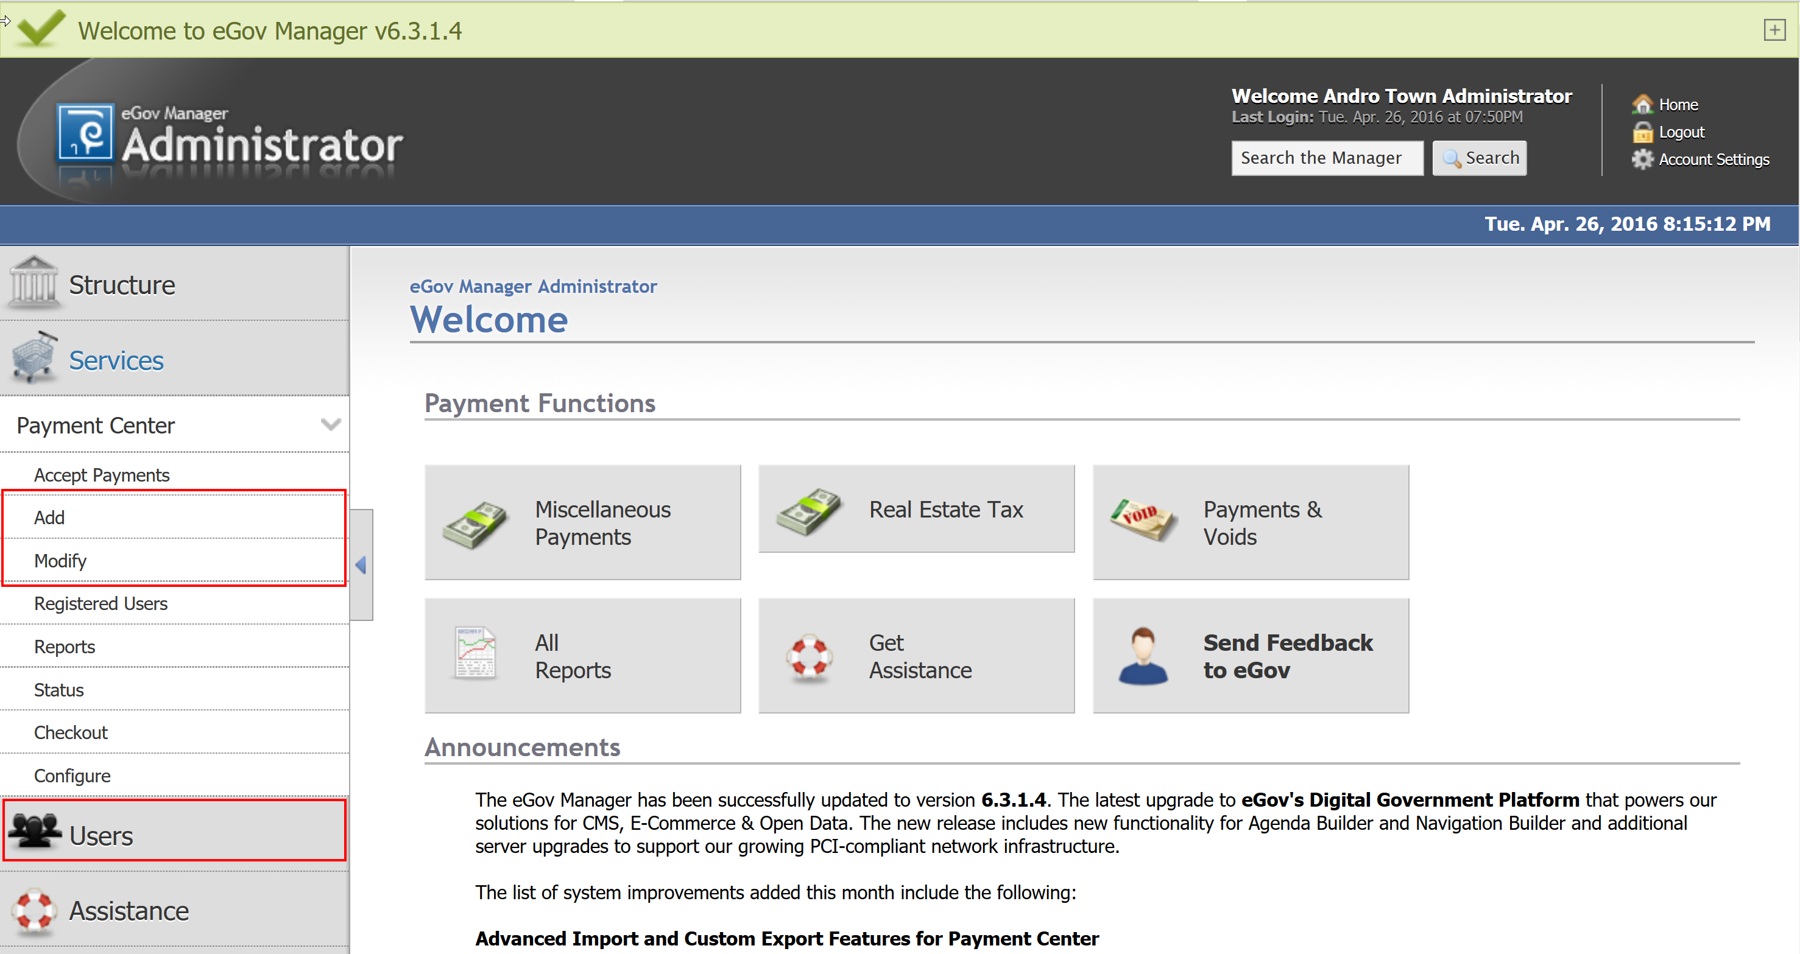
Figure 1 - eGov Manager Payment Functions

Adding eGov Manager Users
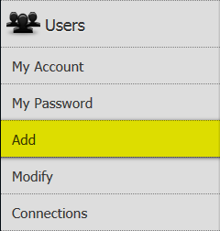
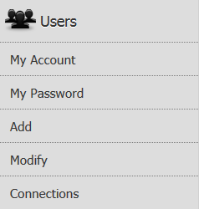
Within the eGov Manager, users are configured with access to specific payment items. BEFORE A USER CAN BE ASSOCIATED, they must be added to the eGov Manager through the Users function within the left-hand navigation.

The Add Option under “Users”
The Add option enables an eGov Manager user to create a new user.
For Payment Center implementations, the process is fairly easy – only one tab is required – the GENERAL tab. To begin, select “Add” under Users.

Process for Adding a New User
Within the General Tab, complete the required items and the following items as noted below:
- LOGIN & PASSWORD
  - User Group = Content Provider
- ACCESS PERMISSIONS
  - Organizations/Divisions = ‘your organization’ (should already be selected)
  - Application Access
    - Choose Edit List and Clear All
    - Services = Payment Center | E-Billing (for importing or exporting)
    - Users
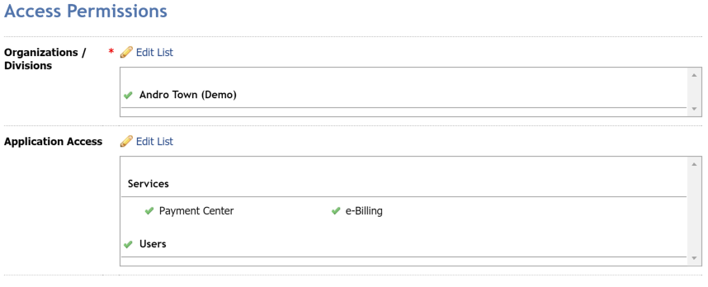

Modifying Your Organization’s Payment Items

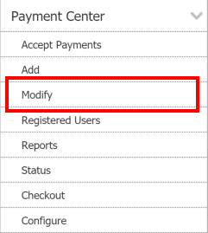
Process for Viewing and Modifying Your Payment Items
Login into eGov Manager: http://androgov.com/manager
Go To Services > Payment Center > Modify (in left hand navigation)
This will result in a list of payment items (see below)
Choose EDIT in front of a payment item
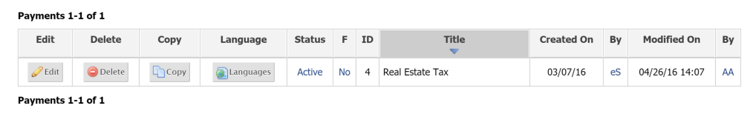

Modifying Payment Items
The three most common scenarios in which you would want to update your payment item are as follows:
- General Tab – to change your payment item’s status, description or instructions
- Confirmation – to update the confirmation messages provided to payers
- User Access – to grant users access to Receive payments or View reports for a payment item
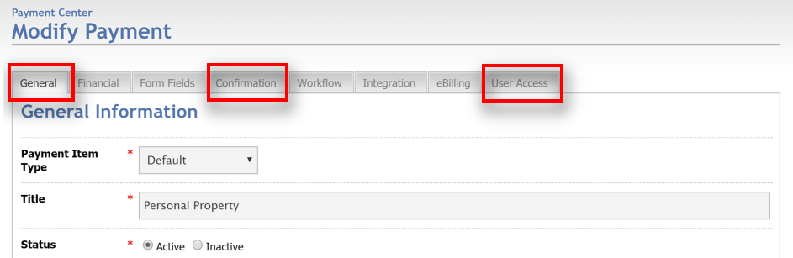
Figure 2 - eGov Manager Modify Payment

General Tab
Items that can be configured include:
- Payment Item Status (inactive – payment item exists but is not available for payment by the public)
- Payment Item Description (appears on the initial page of the payment item);
- Payment Item Instructions (can appear on every page of the payment item);
- Payment Item Activation or Expiration Dates

Confirmation Tab
Items that can be configured include:
- Payment Item Confirmation Message (presented on both the confirmation page and emailed)
- Payment Item Service Norm (presented below the Confirmation message and is generally used to provide payees information about how and when the payment is processed)

User Access Tab
In order to authorize an Administrator or Content Provider to be able to access reports or perform refunds on a payment item, the user must be given specific authorization WITHIN the Payment Item. Assuming that the User is already within the eGov Manager system, do this simple two-step process:

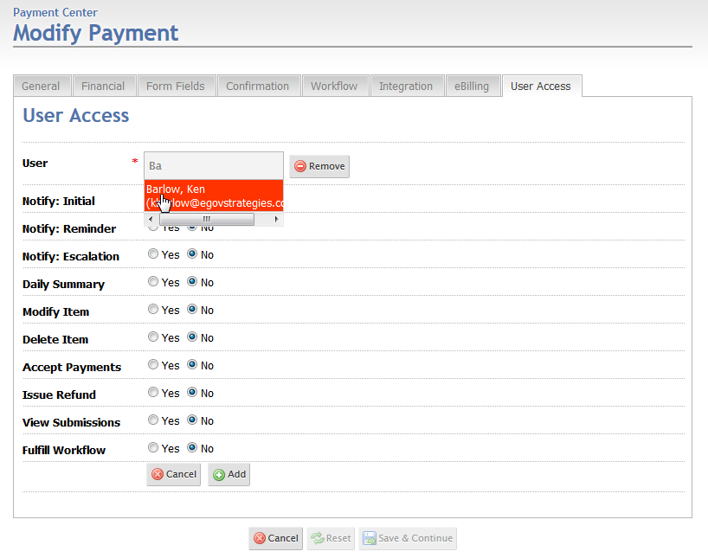
Add User to the Access List
First, ensure that your user is in the User Access list in the User Access tab.
Review the list and if you need to add your user, select “Add” and then type the first few letters of the user’s last name into the box.
When the user’s name appears in BLUE, move your cursor down and select the entry – it will then go RED as shown below.
Note that as long as you have access to a payment item – either you are an Administrator for a department (and thus you get access to all department payment items) – or you are have been granted specific access to Modify a payment item – you can configure any user with access within the User Access tab.

Set the Appropriate Functions for this User
Second, use the radio buttons to assign the appropriate functions to this user.
- Notify: Initial User will receive an email after every transaction for this payment item
- Daily Summary User will receive a daily summary of all transactions for this payment item
- Modify Item User can modify the payment item
- Delete Item User can delete the payment item
- Accept Payments User can take payments via the RECEIVE function
- Issue Refund User can issue refunds under the REPORTS function
- View Submissions User can view submitted transactions under the REPORTS function
- ACH Reports User will receive an email notification for any associated ACH return

Inactivating Payment Items
In the event that you do not wish to allow citizens to make payments via the AndroGov portal, you can either make the payment item INACTIVE or you can remove Public Access.

Set the Payment Item to be Inactive
In the left-hand navigation, select Services > Payment Center > then select the Modify Payments option
Select the ACTIVE link for the payment item – screen will refresh and the payment item will be INACTIVE
Be sure to select the “Show Inactive” option to modify this payment item next time

Adjust the ‘Available to Public’ Setting
In the left-hand navigation, select Services > Payment Center > then select the Modify Payments option
Select the EDIT button to edit the payment item
In the General Tab, set the ‘Available to Public’ setting to NO

Reports & Refunds
The eGov Manager enables authorized staff members to access a wide variety of financial reports regarding payments received via the web and over-the-counter (Office Use Only). Follow the process outlined below to verify that a user has made a payment, find details regarding how they paid, and to generate a receipt, if necessary.

Accessing Reports
After logging in to the eGov Manager, the user will arrive at the eGov Manager home page screen. An authorized staff member can access the payment reporting features in 1 of 3 ways (highlighted below):
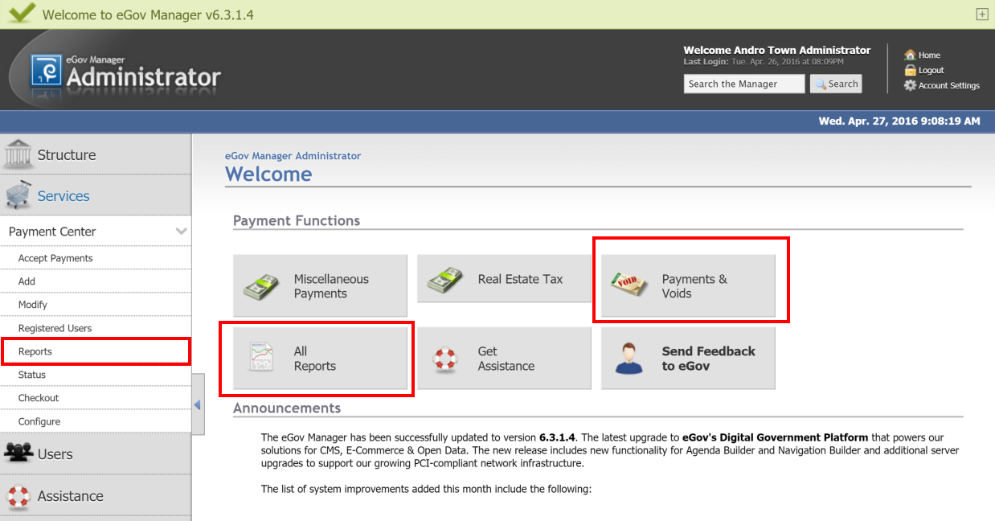
1
2

Quick Access to Reports from ‘Payment Functions’
1

Under the Payment Functions heading on the eGov Manager home page, a user can select one of two options to access the Reports functions:
- Select Payments & Voids to jump directly into the Item Report to view today’s transactions. The report can be filtered further by date range, name, receipt #, etc. and used to display submitted fields. The Item Report is commonly used to access a list of transactions and data submitted for a specific day.
- Select All Reports to jump to the general reports page listing the 13 different report types such as the Transaction Report, the Item Report, etc. Use this link to access the Settlement Summary reports which is used to reconcile against your bank deposits.

Selecting the Reports Function
2

You can also access reporting functions from the left-hand navigation that is always visible during your eGov Manager session – regardless of the functions used within the eGov Manager.
- Under Services in the left-hand navigation, select Payment Center
- The menu will expand and then select the Reports option
There are more than 13 different reports that can be accessed from the Reports landing page. The two most common reports are:
- Transaction Report – list of all transactions where all shopping cart entries are aggregated together;
- Item Report – list of all transactions individually (i.e. all items in a cart are listed separately);
- Settlement Summary Report – used for reconciliation purposes

Item Report: Generating a List of PAYMENTS with Details

Showing Details within an Item Report
An Item Report contains an entry for each item within a payment transaction (i.e., for each item paid for within a shopping cart). Thus, the Item Report is a great way to generate a detailed report of items paid for via the website.
To generate a list of items for a specific day or date range – follow these steps:
- Select the Item Report either from the home page Payments & Refunds button or the Reports page;
- Select the Date Range
  - Choose Custom and enter in a Start Date and an End Date
  - For times, the system will default to 12:00 am and 11:59 pm respectively
- For Item, select the Payment Item (note: important to do this even if you have only one payment item)
- Hit the Run Report button
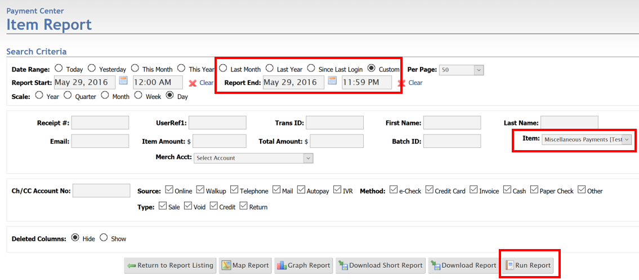

The results are presented in a table with payment information and then select fields. Note the following:
- Use the left arrow key (anchored to the left-hand navigation) to create more display room
- Only fields that have been designated with “Show in Lists” are listed. Edit the Payment Center > Payment Item > Form Fields – or contact eGov Support – to change what fields are listed
- To view all fields, use the Download Short Report option (listed in the screenshot above)
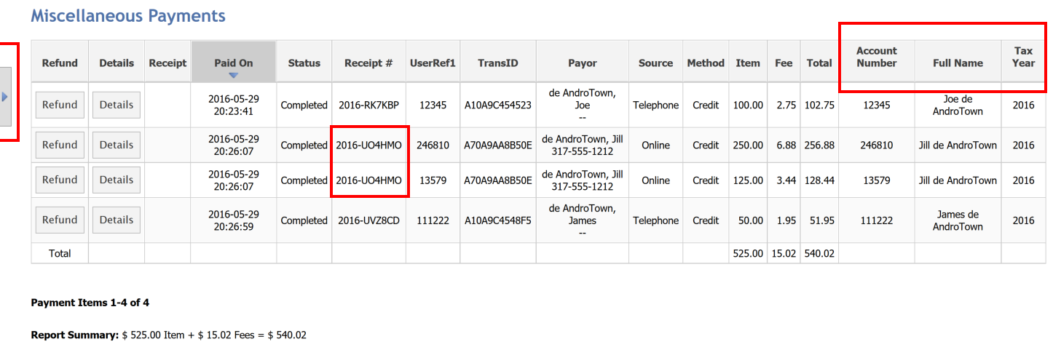
- Items in a shopping cart have the same Receipt number.

Searching for a Transaction Using the Item Report
- Ask for the following information:
  - Last Name, Receipt # (starts with the year, “-“, then 6 alpha-numeric digits) or Account #
  - Date of Payment
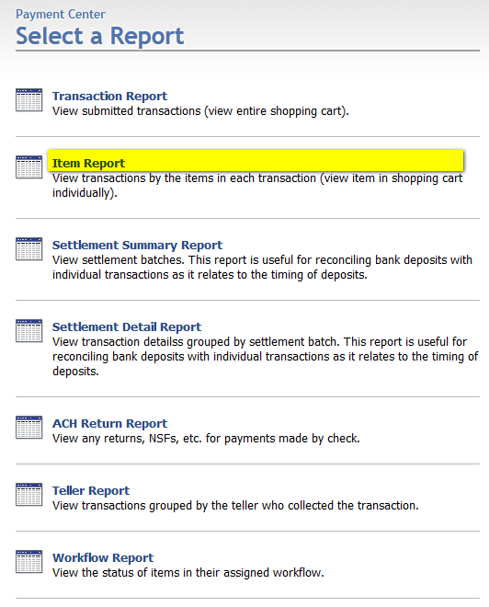
- Select the ITEM REPORT (e.g. Services > Payment Center > Reports from left-hand navigation)
- In the ITEM REPORT, set the Date Range
  - Use “This Month” if payment taken sometime this month;
  - Use “This Year” if payment taken earlier this year; or
  - Use “Custom” to set a specific date range
- Enter any search criteria
  - Receipt # (e.g. 2014-ABC123)
  - Last Name
  - Account # (enter this into the UserRef1 field)
- Hit the “Run Report” button
(farthest button to the right)
See the screenshot on the next page for an
example query with results.

Sample Search Results
A sample screenshot of the results of an Item Report search – searching by Last Name – is provided below. Note that the user selected to run the report using the following parameters:
- Date Range – This Month
- Last Name - Smith
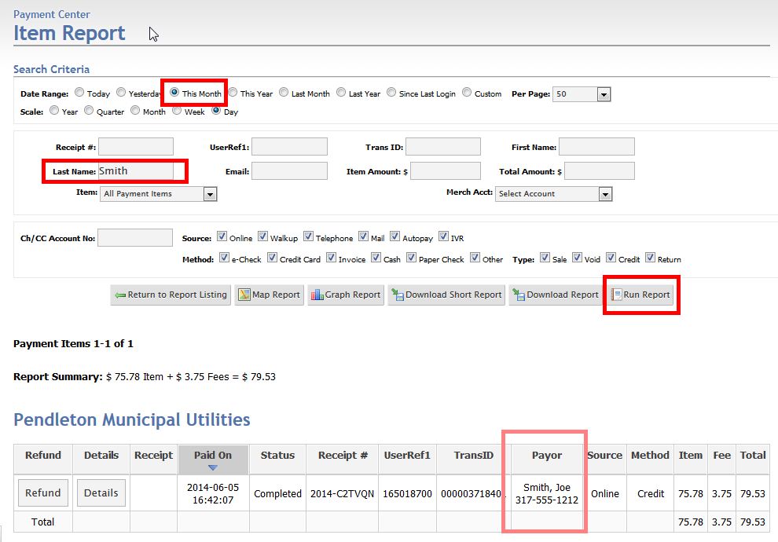
Figure 3 - Item Report w/ Search Results

Getting More Details & Generating a Receipt
By selecting the Details button associated with any of the results that are listed below the row of search options, you can access additional details about a specific payment made via the Enterprise Payment Portal. This is helpful in accessing the following data:
- Customer Receipt – Transaction Type (Credit Card, E-Check), last 4 digits of Card/Account #, etc.
- Order Information – Amount paid
- Submitter Information – Member ID, NCP First & Last Name, NCP SSN (last 4 digits)
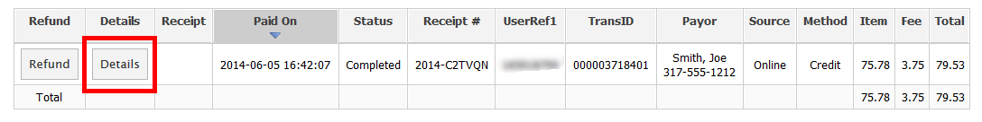

Key Sections within the Item Details Page
- GENERATING A RECEIPT (see the next section in this document)
- ITEM DETAIL SECTION
  - Process Date Time and Day the payment was made
  - UserRef1 Generally, the account number associated with the payment
  - Cost Per Item Amount actually paid for this payment
- SUBMITTER RESPONSES
  - The value of key fields submitted – generally from the Payment Information page that precedes the Payment Information page.

Viewing or Printing a Receipt
To view a receipt for a specific transaction, do the following:
- Select the DETAILS button in front of the transaction;
- Hit the “View Receipt” option on the Item Details page;
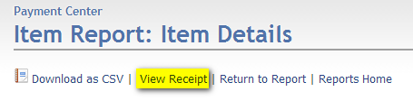
If a user wants to get an email copy, you can either do a screen capture of the Receipt page and email an image or copy the first two sections of the Receipt into an email or Word document – which are the most important:
- Items in Your Cart – a summary of everything purchased during a specific transaction;
- Order Information – Tracking number and payment type details (e.g. last 4 digits of the CC number)
Note that you can also use the “Print this page” button at the top to print a hardcopy or PDF version.

Voiding a Transaction or Issuing a refund
For credit card and debit card transactions, settlement will occur on a nightly basis for all transactions processed at or after 12:00 AM and at or before 11:59:59 PM that same day, local time. Thus, if your organization is in Central time, settlement occurs at midnight Central Time.
To refund someone’s payment, there are two scenarios to consider:
- Same Day (Void) – Up until credit card settlement has occurred, you will be able to void both the payment and the service fee. Use the Search Criteria to filter your transactions (the default only shows today’s transactions) and hit “Run Report”. On the results below, select “Void” in front of the transaction that you would like to cancel.
- Next Day (Refund) – For all other transactions, you can only refund the amount of the payment (e.g. for the utility bill, business license, etc.) but not the service fee as the payment has been processed and credit card fees have been assessed. As above, use the Search Criteria to filter your transactions and hit “Run Report”. On the results below, select “Refund” in front of the payment transaction that you wish to refund.
Note that the Service Fee cannot be refunded for transactions that have settled.

Finding the Transaction
The first step in either voiding or refunding a transaction is to find the actual transaction. Here are the steps for finding the transaction:
- Use the “Reports” function in the left-hand navigation to gain access to a list of reports;
- Select the “Item Report” or “Transaction Report”;
- Enter a date range for when the payment was made (e.g. Today, Yesterday, This Month, etc.).
Select the “Custom” option to provide a specific start date and end date;
- Enter specific criteria about the payment such as:
  - First Name and/or Last Name
  - Email Address
  - Receipt Number
- Hit the “Run Report” button

Sample Transaction Report
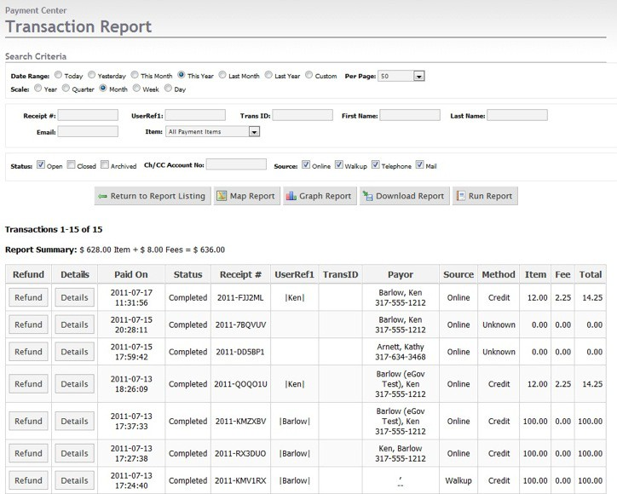
The following screenshot shows a typical transaction report.

Voiding or Refunding the Transaction
Once you have found the transaction in the transaction report, proceed as follows to either Void or Refund this transaction. A void for the payment transaction and the service fee will occur if this transaction has not cleared (e.g. for same day transactions). A refund for only the payment transaction will occur if this payment has already cleared.
- Confirm as much information as you can about the transaction to be refunded. Note the following fields:
  - Payor Column – confirm First Name, Last Name and Phone Number;
  - Item Column – confirm amount of the transaction;
  - Fee Column – confirm the amount of the service fee and note to the payee whether this will be refunded or not;
- Select the REFUND button in front of the transaction to be voided or refunded;
- On the next screen, confirm that you wish to refund the transaction. ;
- Notify the payor that they will receive a confirmation email as their receipt.
To provide the payor with some expectation on when the refund will take place, note the following:
- For voids, the transaction may have already hit their bank account or credit card account but it will be removed by the next morning.
- For refunds, it may take 3-5 business days for the transaction to be credited to their bank or credit card account.

Void & Refund Policies
Note that voids and refunds can only be done for the ENTIRE transaction amount. Thus, if an overpayment is made, the initial payment will need to be voided or refunded and then the payee must make the payment again at the correct amount.
If the refund occurs after the payment has cleared, the payee will be paying two service fees (e.g., the initial service fee will not be refunded).

Settlement Reports
The eGov Manager enables authorized staff members to generate settlement reports to enable them to reconcile payments made through the eGov Enterprise Payment Portal with deposits made to into their bank accounts due to these transactions. The two most helpful reports that are available within the Reports section for handling reconciliation are:
- Settlement Summary Report – a break-down, by settlement date – of all deposits made into a specific account (referred to as ‘settlement batches’). As you can see from the screenshot below, Credit Card payments is one settlement deposit to be reconciled and the ACH payments is another settlement deposit to reconcile;
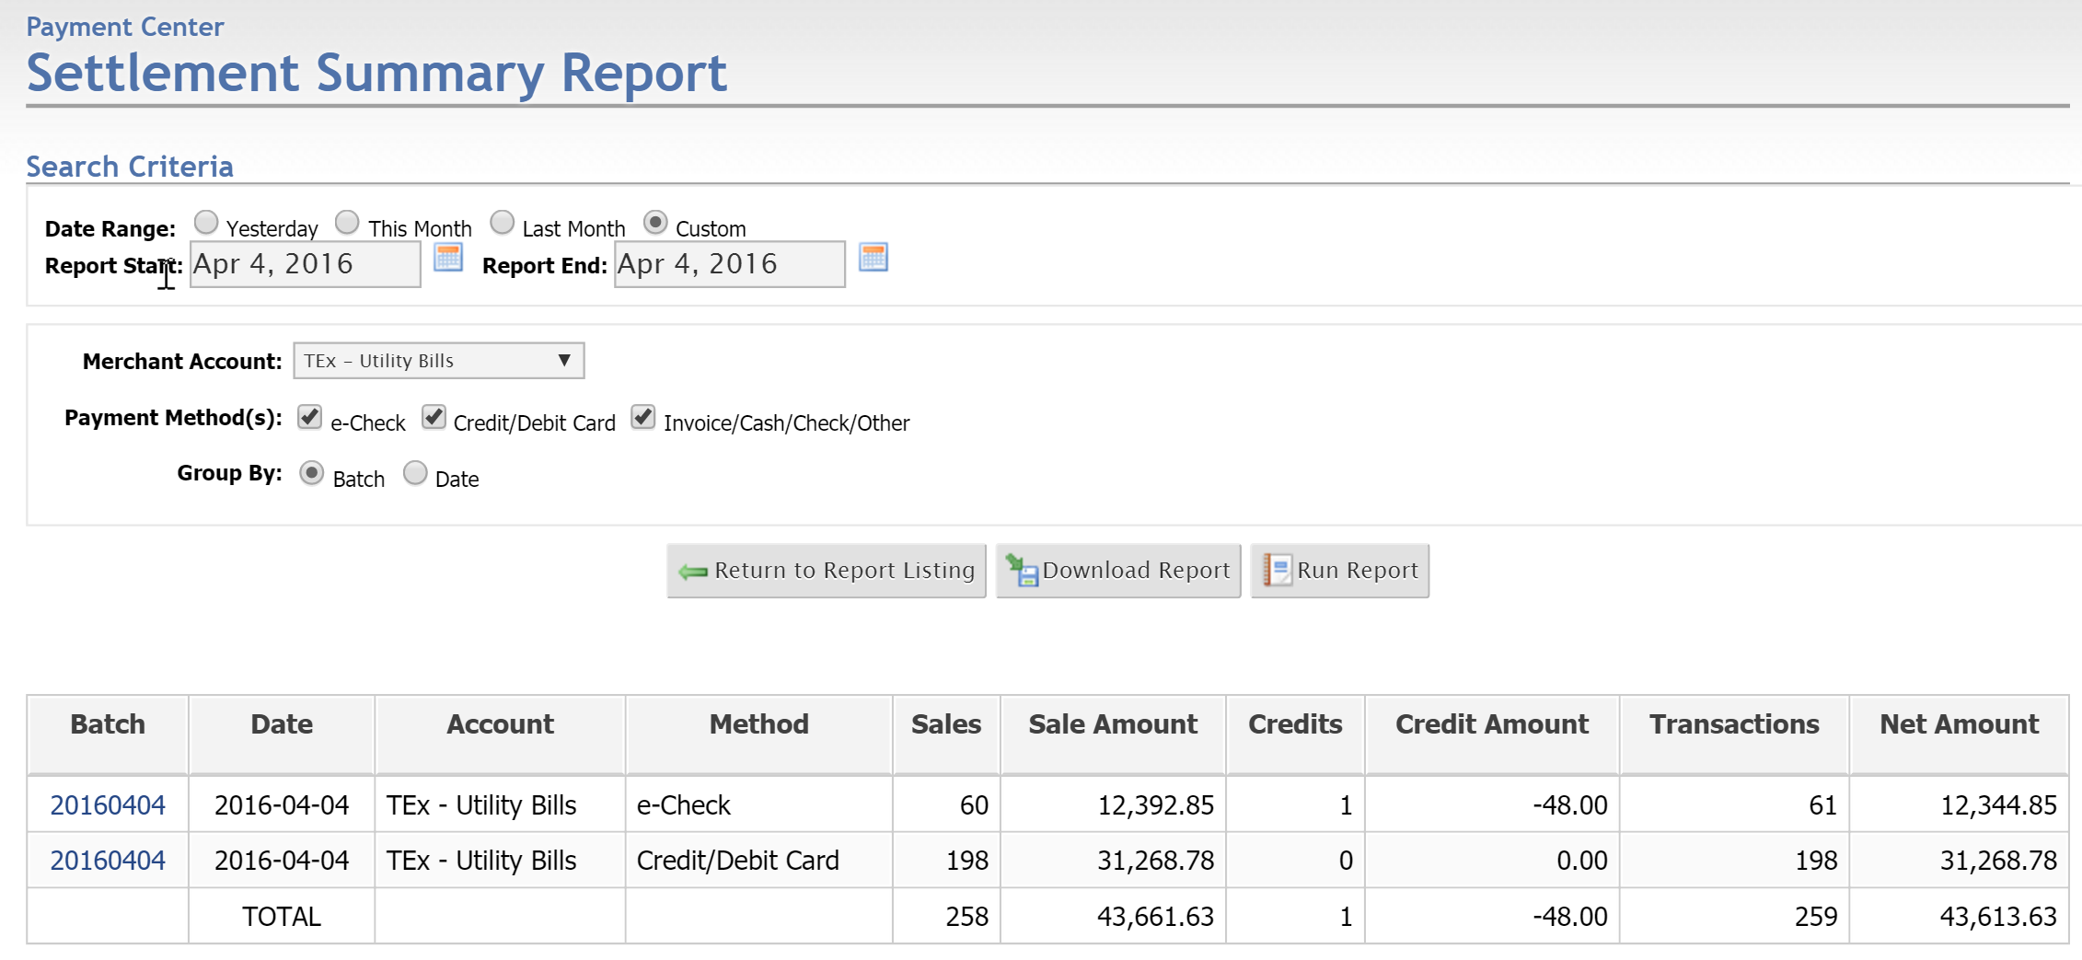
Figure 4 - Example of 2 Settlement Deposits (1 for ACH and 1 for Credit Card)
- ACH Return Report – a list of the ACH credits for a specific date range. A user can identify the specific payor responsible for a credit that appears in the Settlement Summary Report for e-Check (ACH) transactions – for example, for the $48.00 credited above.
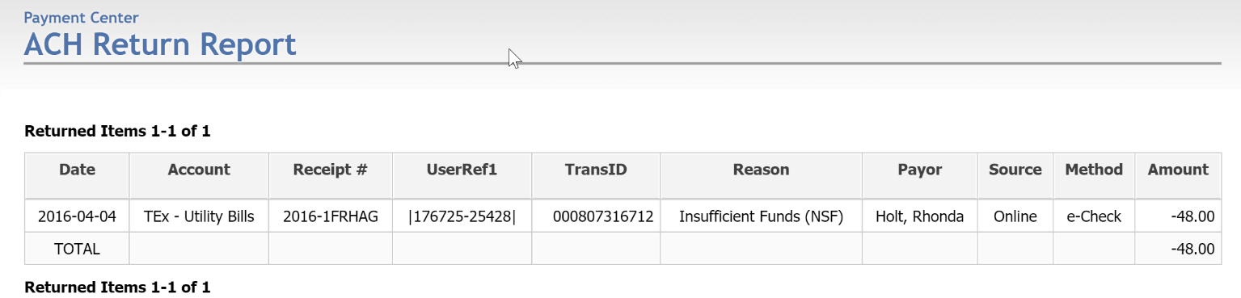

- Settlement Details Report – a more detailed report of all of the transactions that comprise a specific settlement batch listed within the Settlement Summary Report – similar to the Transaction Report.

Reconcile Credit Card Transactions
- The bank deposit for credit and debit card transactions made for a particular day is made 2 business days following the day of the transactions (all payments made on Tuesday before midnight are in the bank as a single deposit Thursday morning).
  - For payments made on Friday, Saturday and Sunday before midnight ET, Androscoggin Bank will make three separate deposits for those funds – and all will be available Monday morning.
  - In the event that the balances do not match between your settlement summary report and your bank deposit, contact eGov Strategies (www.androgov.com/support) and we will help you reconcile the situation.

Reconcile E-Check Transactions
- The bank deposit for E-Checks made for a particular day is made 1 business day following the day of the transactions (all payments made on Tuesday before midnight are in the bank as a single deposit the next business day – Wednesday morning).
  - For payments made on Friday, Saturday and Sunday before midnight ET, Androscoggin Bank will make three separate deposits for those funds – and all will be available Monday morning.
  - In the event that the balances do not match between your settlement summary report and your bank deposit, consult the ACH Return Report within the Reports section.
  - In the event that the balances do not match between your settlement summary report and your bank deposit, contact eGov Strategies (www.androgov.com/support) and we will help you reconcile the situation.

Generate a Settlement Summary Report for the Month
The following instructions provide additional details with respect to reconciling payments at the end of the month using the eGov Manager’s Settlement Summary Report.
- Under Services > Payment Center, choose Reports;
- Choose the Settlement Summary Report;
- Since it takes 2 business days for payments to settle, you should set the Date Range using the Custom option:
  - Begin 2 business days before the end of the month (e.g. for the February Report, start at 1/28)
  - Run the report until the end of the month (e.g. 2/28) – note that you will not be reconciling the last 2 business days
- Hit “Run Report” to see that the report produced the appropriate values;
- Hit “Download Report” – this will open the report you see on the screen in MS Excel;

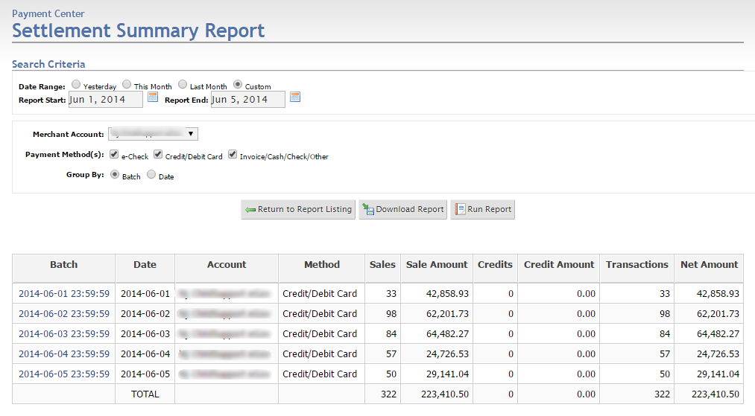

The Settlment Details Report
To view the specific transactions that occurred for a specific date (batch), select the link under the Batch column. This will take you directly to the Settlement Details Report for that date/batch.

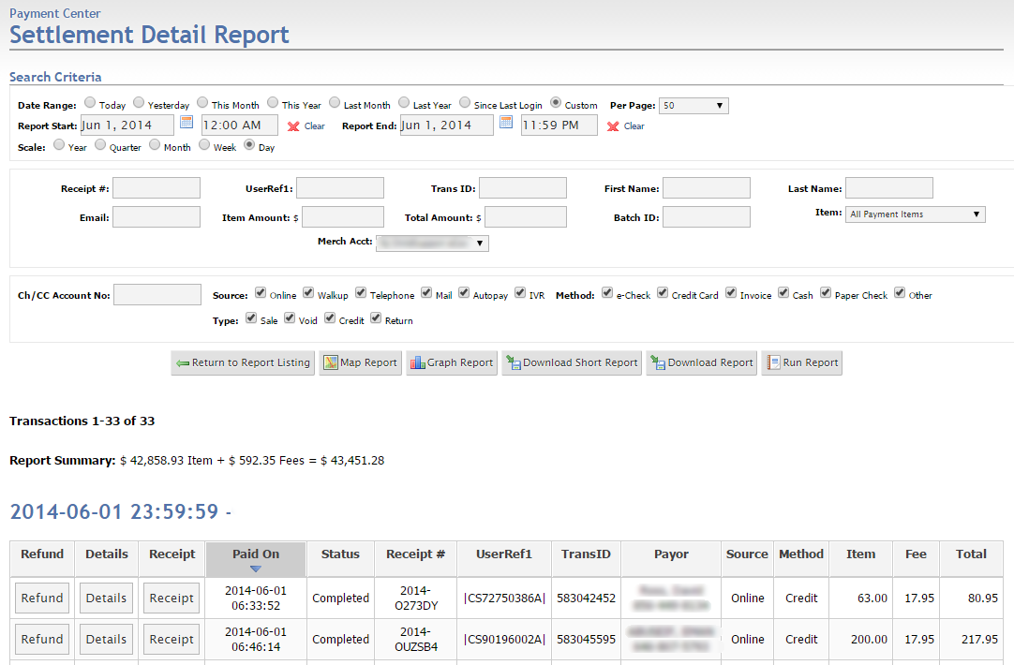

Note Regarding Credits And Adjustments in Settlement Summary Report
Keep in mind that in some cases, your bank balance may be affected by credits that are settling for a specific settlement batch. Just as payment amounts are added to your bank account, credits are removed from your bank account.

Match Deposits to Specific Bank Deposits
- The next step is to then match each net deposit amount to the bank deposits made. Here are a couple of guidelines to keep in mind:
  - Credit card and e-check deposits are generally deposited 2 business days following the day of the transaction (payment on Tuesday before midnight is in the bank Thursday morning);
  - Payments made on Friday, Saturday & Sunday will be listed in the eGov report in order as deposited 2 days later (on Tuesday) BUT WILL NOT necessarily be listed that way in your bank statement. The reason is that your bank will SORT the deposits – ordering the deposits from smallest to largest. For example:
SETTLEMENT SUMMARY REPORT |  |  | BANK STATEMENT
Date | Net Amount |  | Deposit Date | Amount
Fri 2/7/2014 | $2,404.40 |  | Mon 2/10/2014 | $558.00
Sat 2/8/2014 | $558.00 |  | Mon 2/10/2014 | $627.90
Sun 2/9/2014 | $627.90 |  | Mon 2/10/2014 | $2,404.40
- eGov suggests using MS Excel to reconcile your bank statement against the Settlement Summary Report. Here is one way that this can be done:
  - ADD A COLUMN TO COMPUTE THE DEPOSIT DATE
- Run the Settlement Summary Report as outlined above and open the resulting spreadsheet;
- After the last column, add a column to calculate the Deposit Date;
- In this new column, use this formula to calculate the Deposit Date
  - Make sure this column is formatted for Short Date
  - Assuming that the date is in column A, set the formula as follows:
    - =workday(A2,2,*)
    - For the *, add in any holidays in this format: DATE(2014,2,17)
    - Formula for February should be: =workday(A2,2,DATE(2014,2,17))
  - Repeat this formula for all of the entries in this column
Note re: dates – you can use a list of dates if you’d like rather than a single date, just put them into your spreadsheet in a list using the format above (e.g. =DATE(2014,2,17)) use a formula like:
=WORKDAY(A2,2,$L$33:$L$35) – where 3 holiday dates are in the cells $L33 to $L35.
- ADD A COLUMN FOR THE DEPOSIT AMOUNT
- After the Deposit Date column, add a column for the Deposit amount
- From your bank statement, add the Deposit amount for each Deposit Date in the last column

Contacting eGov Support
In the event that there is an issue with the payment portal website, please contact eGov Strategies support by email at support@egovstrategies.com or call 877-634-3468 extension 2.

Information to Provide With Your Support Request
- Name, Phone Number, Email Address & Name of your Community
- Whether the problem is with a Payment Form being submitted by a constituent or with the eGov Manager
- Type of Browser that you were using
- Preferred - Steps to Recreate the Issue

